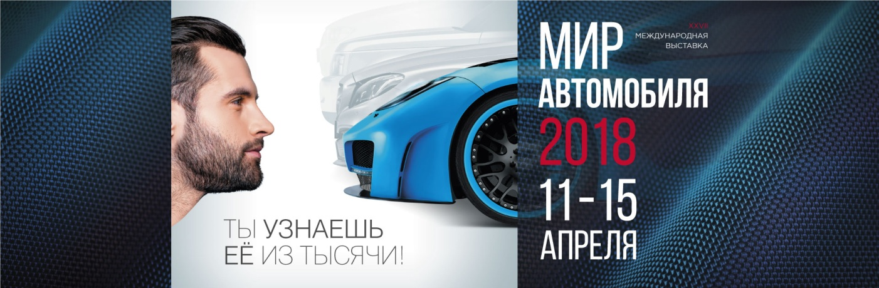

Press Badge Application Form

The editorial office of ______________________________________ plans to cover the Auto World Motor Show. In this regard, we ask you to register the following employees for work at the exhibition from 11 to 15 April, 2018:

Full Name | Position | E-mail
1.

2

3

4

Mass Media Background

Mass Media Type: _______________________________________________________________

Specialization: _________________________________________________________________

Program’s Name (for TV and Radio): ______________________________________________

Address: ____________________________________________________________________

Phone: _______________________________________________________________________

http:__________________________________________________________________________

Estimated Publication Date: _____________________________________________________

To submit an interview with the Motor Show Director or visitors and honor guests, please indicate (person, date and time): ___________________________________________________________________________

Full name (Chief Editor / Program Manager):
__________________________________________________

- To register please return form to Julia Sakharova - fax: +7(812) 777-04-07 or on e-mail: sj@farexpo.ru
- The number of journalists for print, radio and Internet media - maximum of 2 people, for television - 4

